Koala are on the move!

As you know, we have been working very hard to secure our new space at 83 High Street. We have already received funding from Test Valley Borough Council and Councillor Phil North and hope to start work on the building in July, with the aim of moving during September!

Unfortunately, we have to leave Incuhive, due to another tenant moving into the space, and have been looking for a building that we can occupy on a temporary basis while we make 83 High Street our final home.

Our friends at Purple Oak have very kindly cleared some space for us on their ground floor (where the nursery is currently situated) and we will be moving week commencing 24th June to our temporary space.

Anyone who has visited Purple Oak will know that the centre is extremely friendly, fully accessible and has a wonderful sensory room (that we will have access to during our sessions!)

We will have our own entrance to the Purple Oak building and there is ample paid parking at the back of the building (Winchester Road Car Park). The space (on the ground floor) that we will occupy is exclusively ours while we are renting the rooms.

We will be open on Monday 24th June, for our daytime adults sessions, but then CLOSE until Monday 1st July, when we will reopen at Purple Oak and our sessions will commence as normal.

We will release a video of the space at Purple Oak on Thursday 20th June and Tori will be doing a live facebook session (the same evening) to answer any questions.

As ever, we will do everything we can to make this temporary transition as easy for our community as possible so, while we work behind the scenes to create videos and pictures of the temporary space, please email us on hello@moreeducation.co.uk if you have any questions or concerns.

Easy read

 | Builders will be working on our new home at 83 High Street in July and August
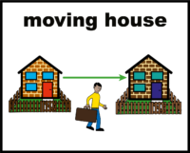  hub | But we have to move our hub while this work is being done
 | We have to move for 2 months
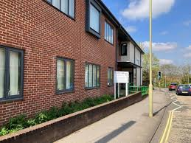 | Koala will be at Purple Oak for 2 months
 | We will close on Monday 24th June (after adults day group).
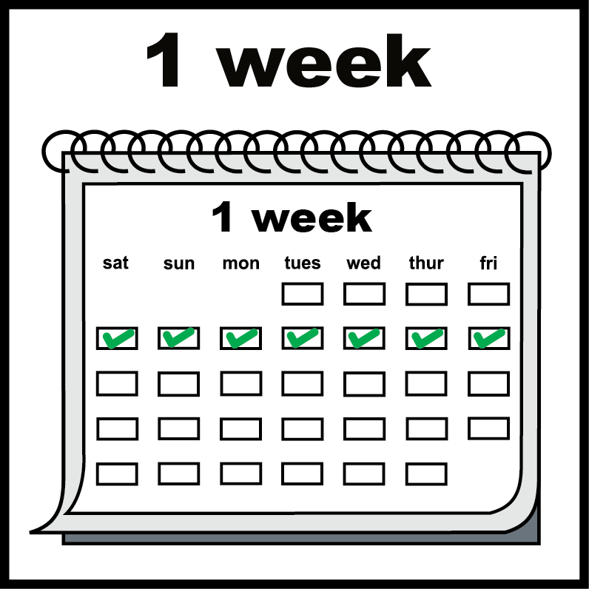 | We will be closed for 1 week
 | We will open again on Monday 1st July at Purple Oak
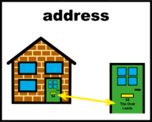 | We will have our own front door to the building
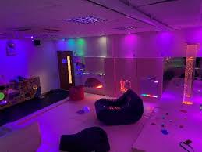 | We will be able to use their lovely sensory room
 | Purple Oak also supports disabled people so is a good place for us to be
 | We will put a video on Facebook on Thursday so that you can see the new space
 | Tori will also do a Facebook live on Thursday night so you can ask any questions
 | You can email us at hello@moreeducation.co.uk if you have questions

